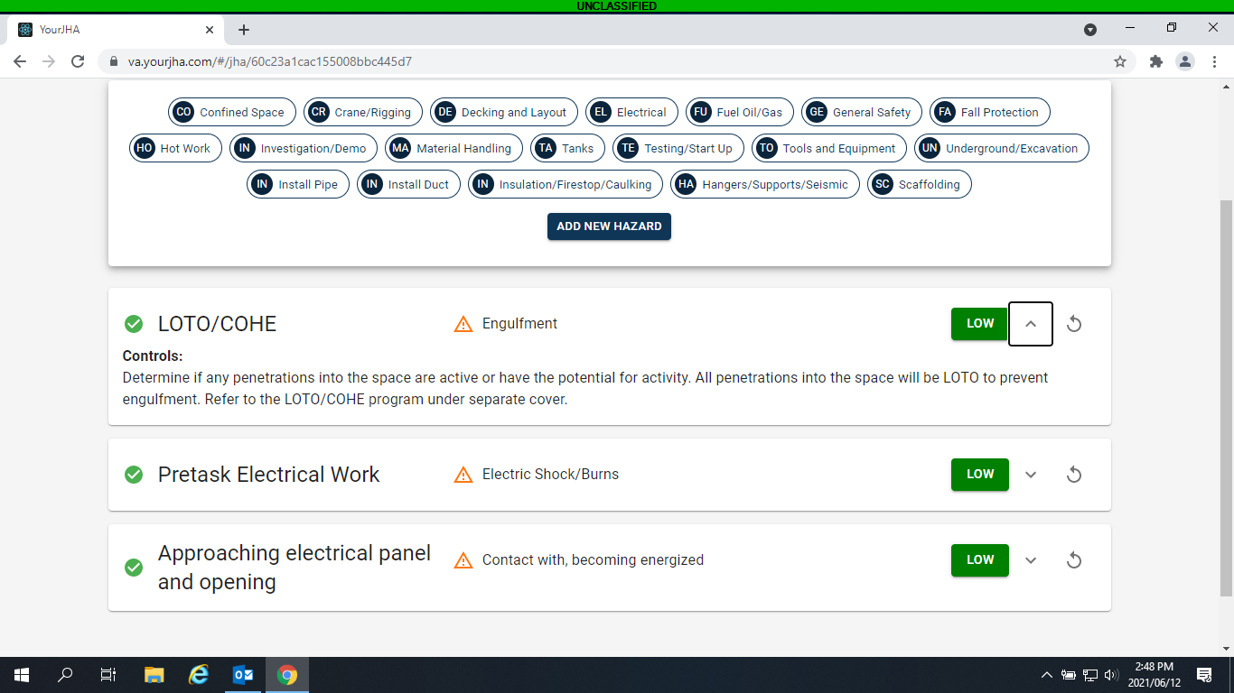

When we refer to something, can we provide a link to the referenced material (SOP, Policy, website, etc.)

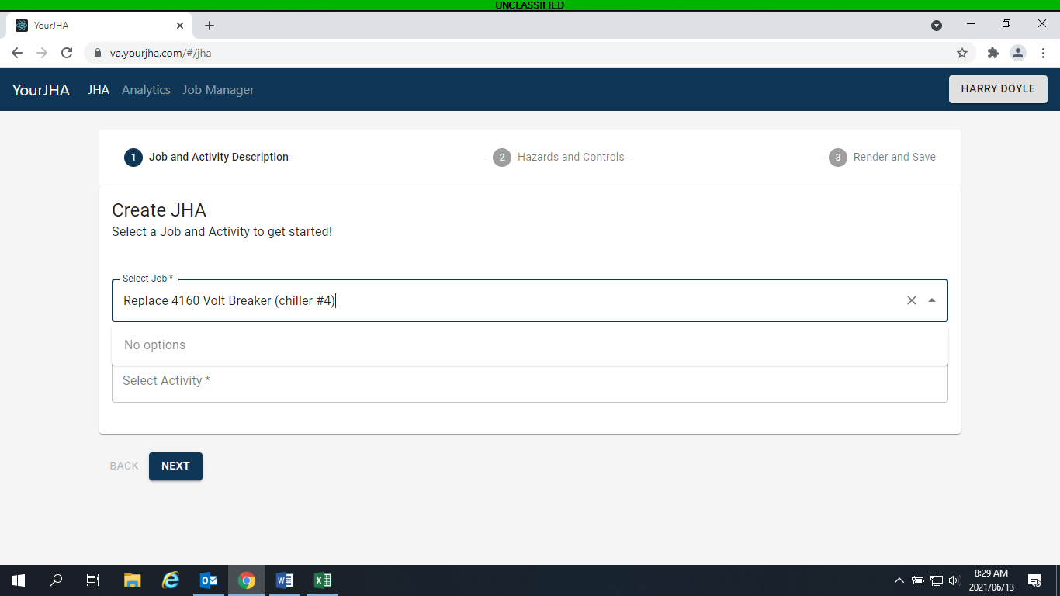

When on the “Create JHA” Page, if you add data to one of these selections, and then go to the other section, the data doesn’t stay. Select Job & Select Activity.

When on the “Create JHA” Page, if you add data and then go to another window, the data is gone when you return. I want my data to show:

“600-21-017-MS - Replace 4160 Volt Breaker (chiller #4)”

I later figured out that I had to create a “Job” first from the Job Manager page, then add data here. May be nice to add “Jobs” here as well.

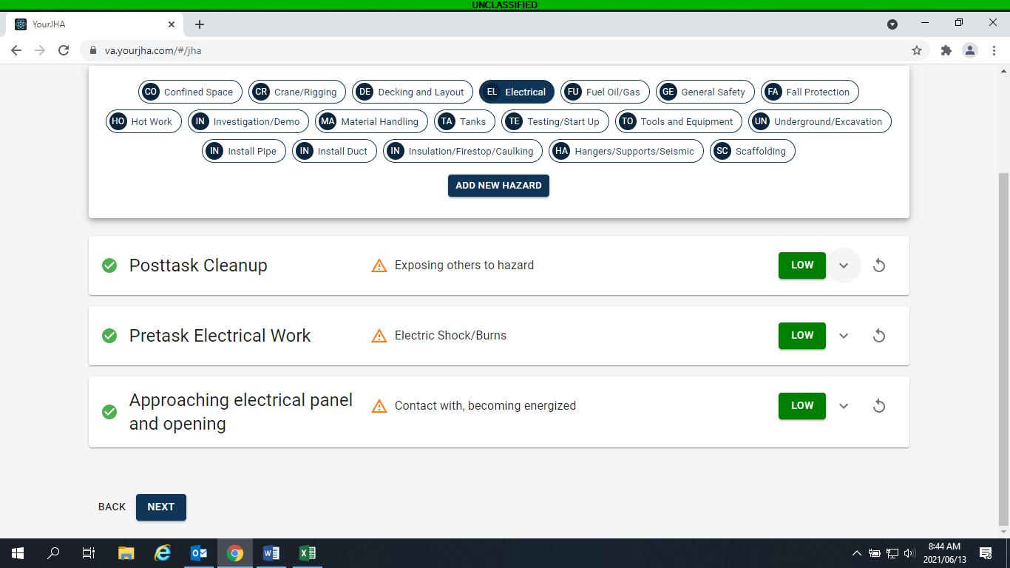

When the curser hovers over these three options, a brief description would be nice. i.e. what do these buttons do?

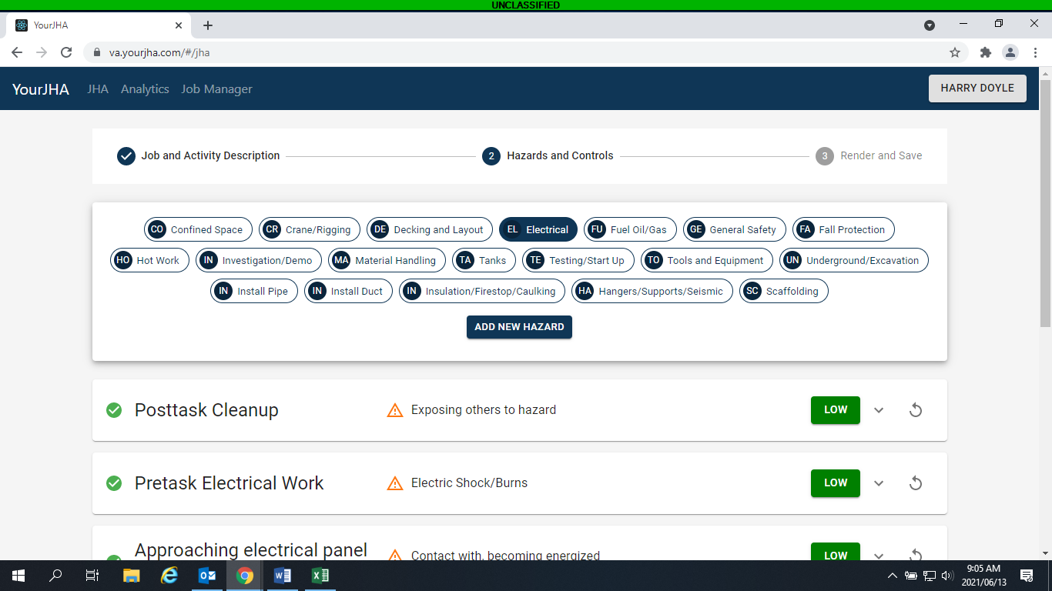

When selecting multiple Hazards, can we only show the Hazard selected. When multiple are selected, there seems to be too many items below. Or we can sort them.

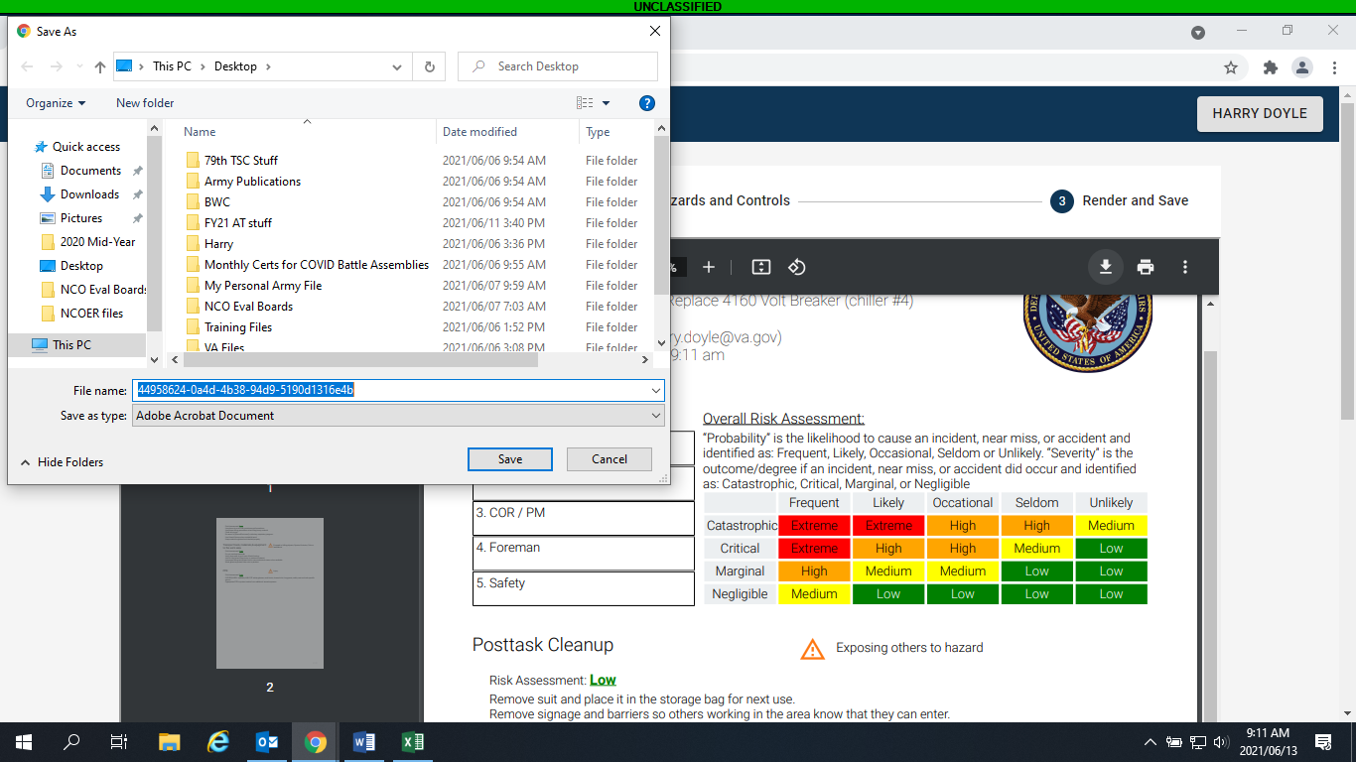

When downloading, can the File Name start with something associated with the “Job Name – Task - Date”:

600-21-017-MS - Replace 4160 Volt Breaker (chiller #4) - Replace Breaker – 06.13.2021

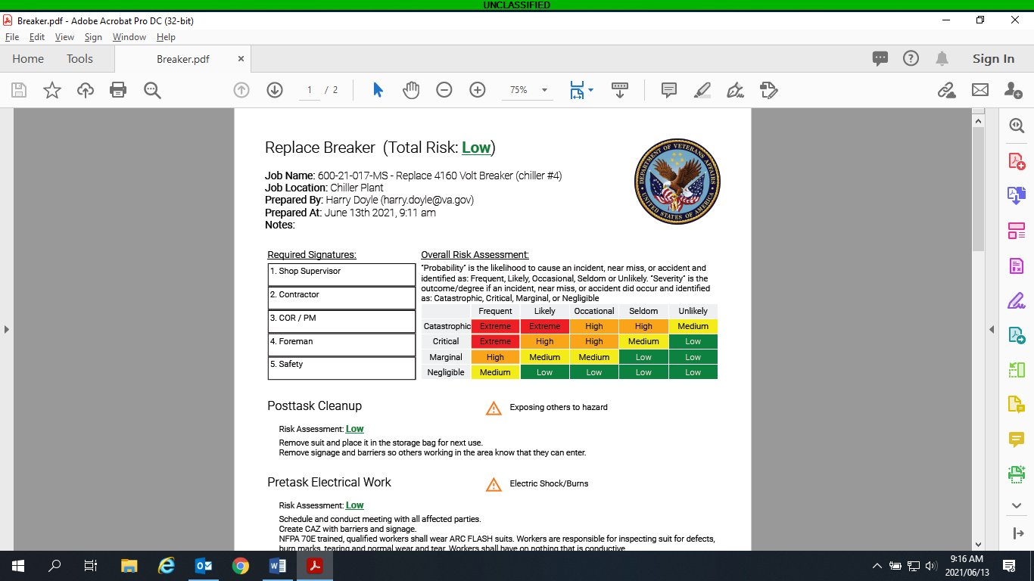 Instead of this

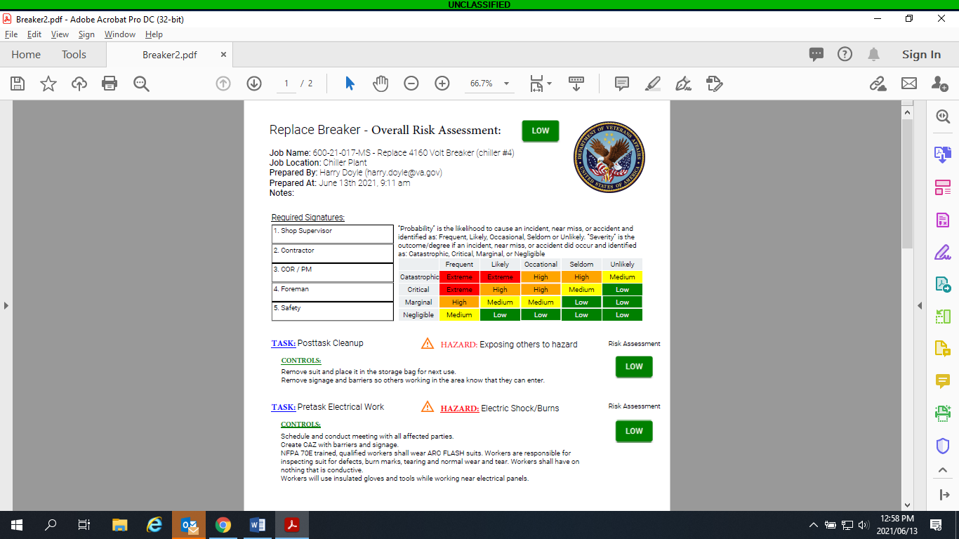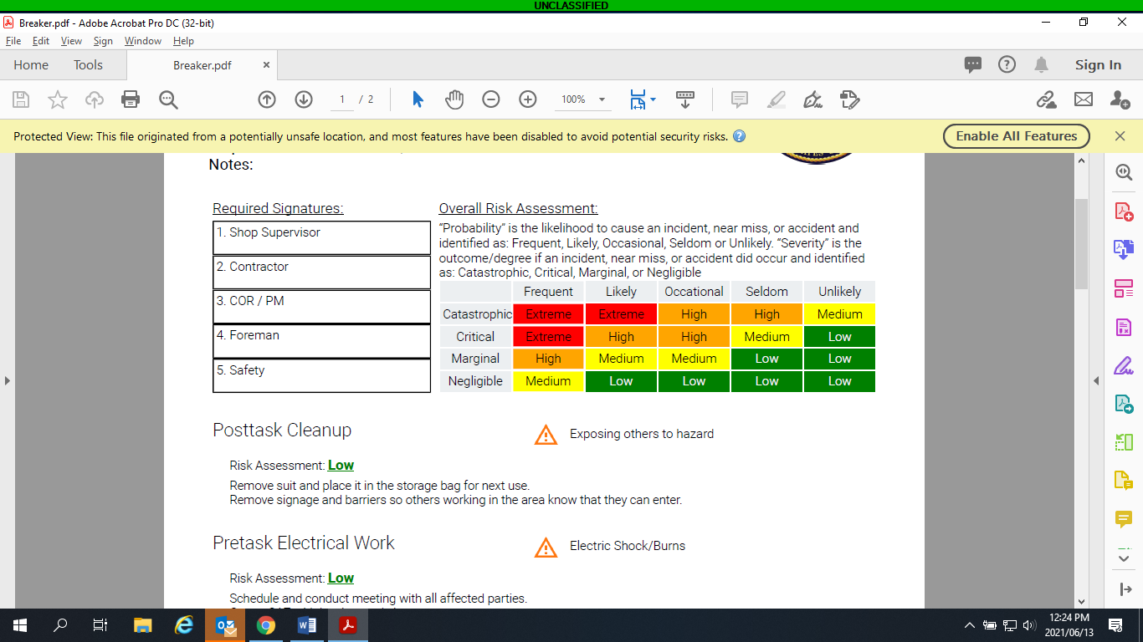 More like this maybe??